**Clipboard:**

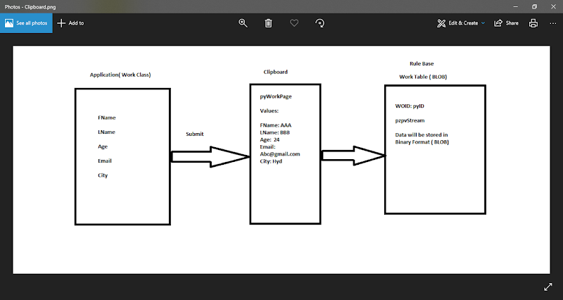

* **Clipboard is a Debugging Tool**
* **Clipboard acts as Interface b/w PRPC application & Rulebase/ Application & External Apps/Application & External databases**
* **Clipboard is a Visual representation of your Work Object Data. In Clipboard we can see Data also we can Update the Data.**
* **Clipboard is a temporary storage location b/w PRPC application & its rule base**
* **In Clipboard  WO data will be there under user pages & we can see data under a default userpage pyWorkPage**
* **In Clipboard WO will assigned to an predefined property pyID(Thread) under pyWorkPage**
* **pyWorkPage is Reference Page For WorkLayer & Work Classes**
* **pyID is class key for is class group/belongs to class group**

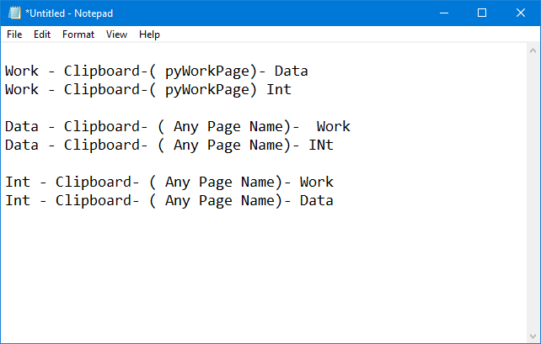

**When working on any transaction we can see WO Data in the clipboard until the work object is open. If we close the WO, data in Clipboard will be lost. Also U cannot see pyWorkPage under  userpages.**

**How to Debug/ See WO Data in Clipboard:**

**Run Customer Flow & Enter WO Information & Submit**

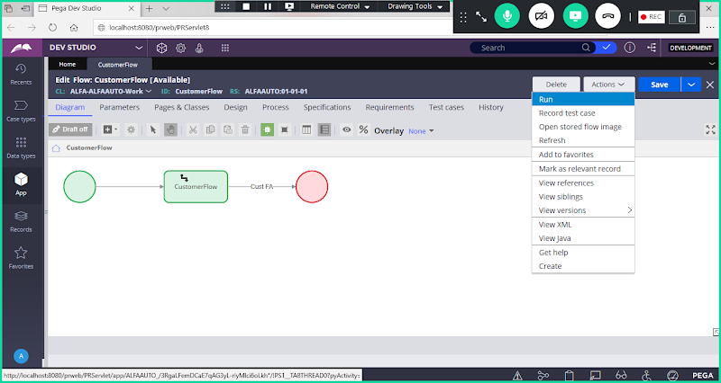

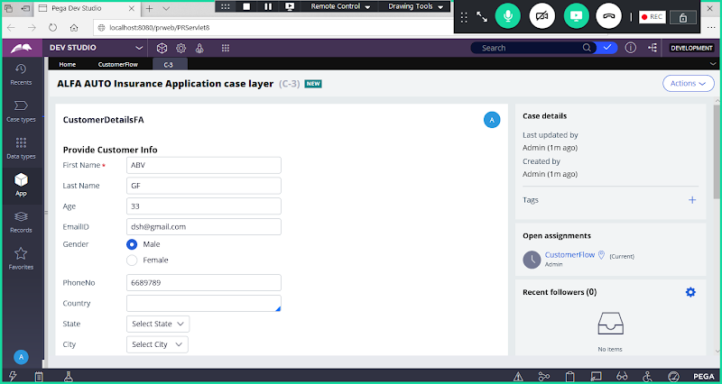

**Click on Submit**

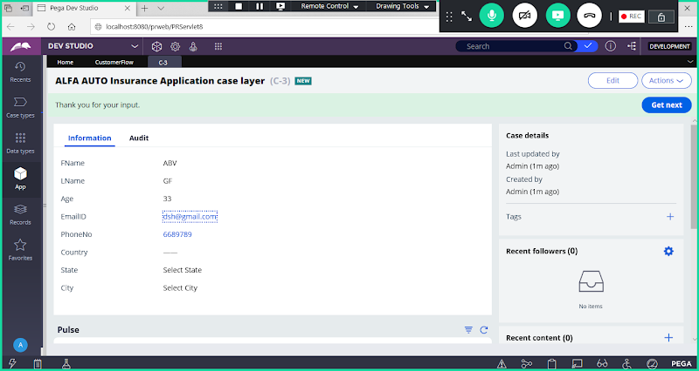

**Open Clipboard from Toolbar Panel:**

**Now Open pyWorkPage from userpages**

**Search for pyWorkPage & Open the page**

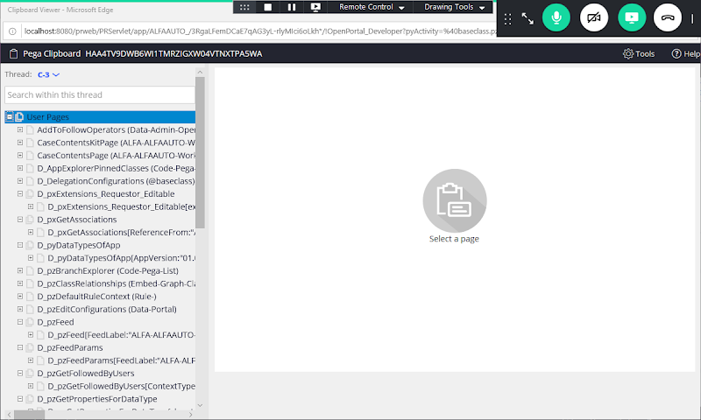

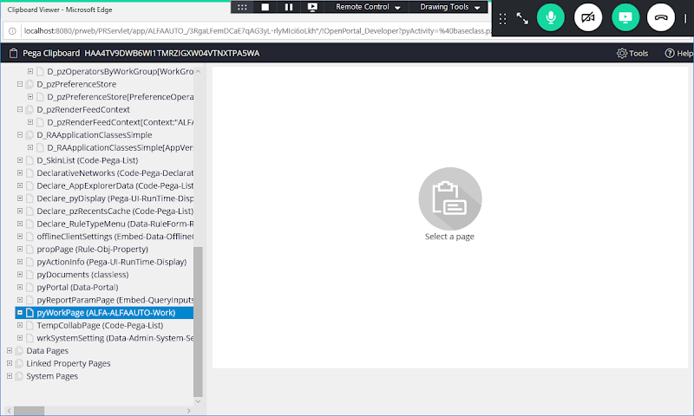

**Click on pyWorkPage**

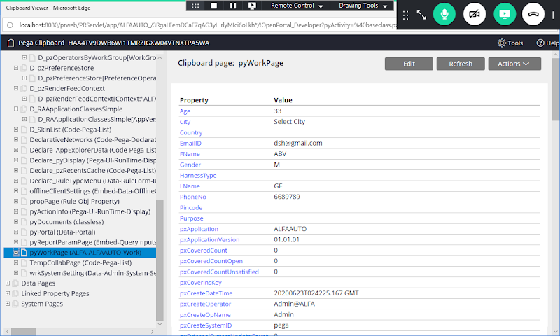

**Click on Edit**

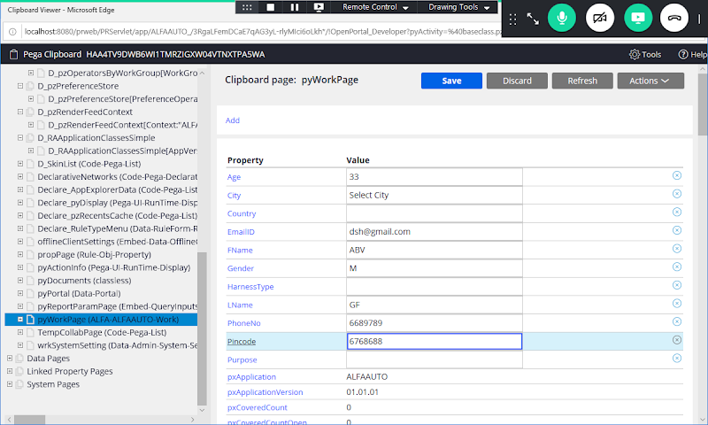

**Click on Save**

**Where to see list of WorkObjects( WorK ID's)  in PRPC Application/Platfrom?**

**Ans:  Click on Class group.**

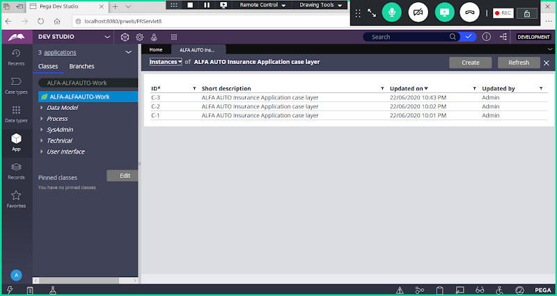

**========**

**In PEGA PRPC Built-in Rule will start with px, py & pz:**

**px : Read Only / No Write**

**Ex: pxTextInput, pxInteger, pxDropdown, pxRadiobuttons**

**Property-Set**

**pxProperty    =  Value (Not Allowed)**

**User Defined Property   =  pxProperty (Allowed)**

**py : Read /Write**

**Ex:  pyid, pyWorkPage,  pyStatusWork, pyAccessGroup**

**Property-Set**

**pyProperty    =  Value (Allowed)**

**User Defined Property   =  pyProperty (Allowed)**

**pz : No Read / No Write  (Only for Internal Usage)**

**Ex: pzInskey, pzpvstream**

**Property-Set**

**pzProperty    =  Value (Not Allowed)**

**User Defined Property   =  pzProperty (Not Allowed)**

**There is a Scope to update px Rules, we can use a method Property set special**